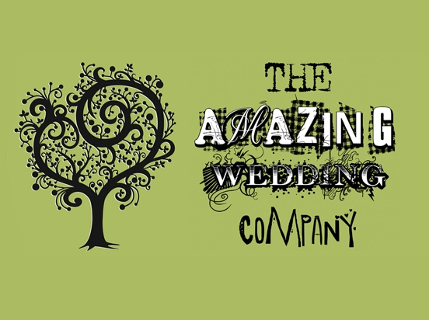  York Maze is a fantastic rural venue, perfect for the less formal wedding or reception.  When we close as a visitor attraction we take down all the maze related paraphernalia and return the site to the beautiful farmstead it naturally is.  We are located in the open countryside on the way to Elvington, on the south side of York. Although we are in the countryside, we are only 7 miles from the city centre.  We will work with you to make the day your own, you can use the site as you wish, decorate it as you wish and we can do as much or as little as you want.  So many places do not give you the freedom to create your own special day. |  |  | For more information about our venue please contact Vikki on:  Phone :01904 607341  Email: info@theamazingweddingco.co.uk  Web: www.yorkmaze.com/events/weddings/  Our aim is to give you the Wedding you wish for. |  |  | “If you want the most relaxed, care free wedding day book York Maze. We looked at quite a few barns in North Yorkshire before we made our decision but none of them had the personality and relaxed feel that the Maze had. You can completely put your own stamp on the maze as it is a blank canvas. but that's part of its charm with exposed brick work and wooden barn. The actual day surpassed all my expectations, I can't thank Vikki the wedding coordinator enough for how smoothly she ran everything. We're wondering how soon is too soon to renew our vows just so we can have another event at the maze.” Laura and Thom – May 2017

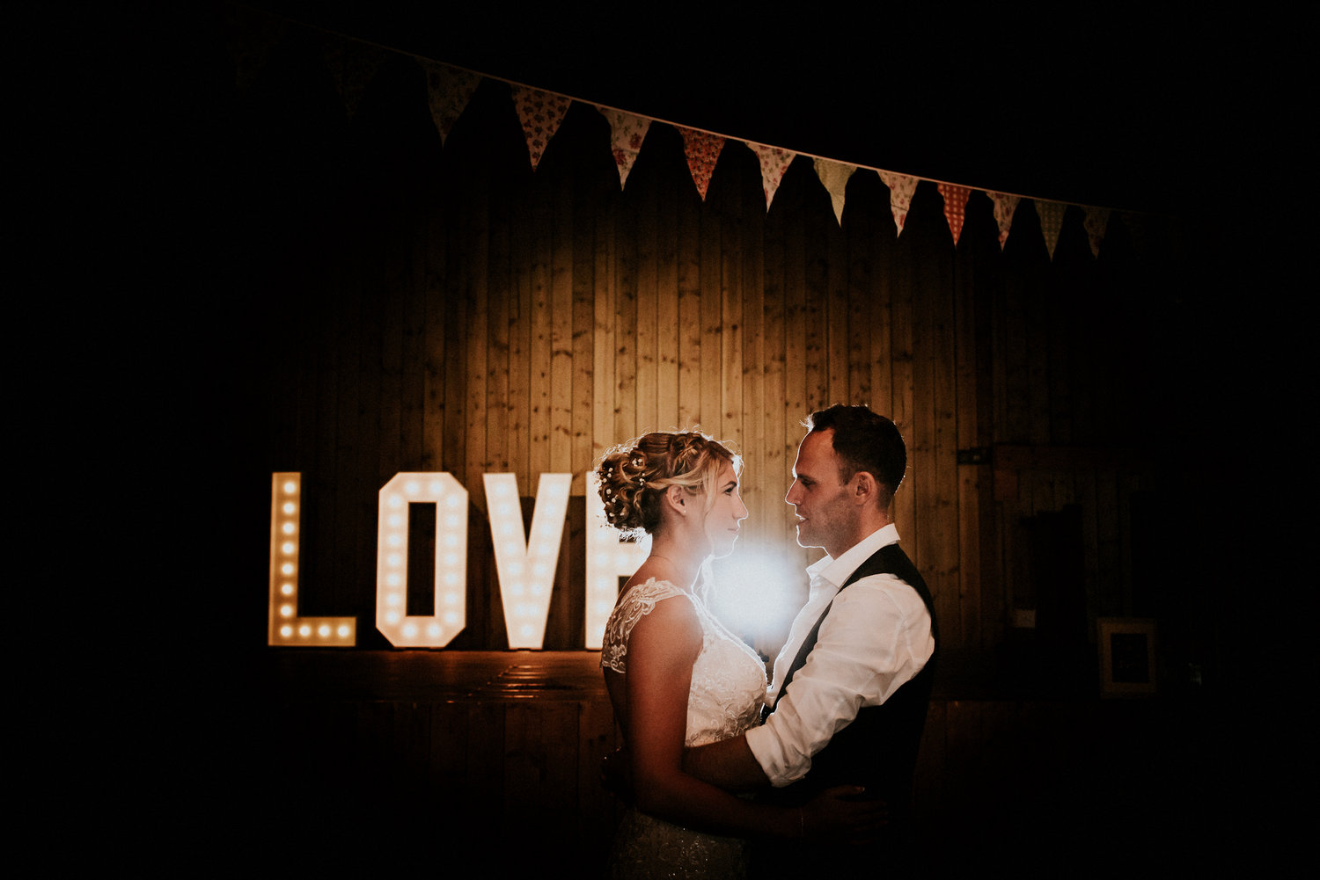  The Facilities  The Barns…  We have a wide range of brick and timber barns, connected to a south facing wooden terrace which is covered by a barn with optional removeable sides.  The larger timber barn has a stage at one end, ideal for bands or DJ’s.  And a smaller stage at the other for the ceremony.  We charge £7000. This is for a 3 day exclusive hire (8am Friday – 3pm Sunday). Then there would be the catering cost on top of this.  For more information or to book to come and have a look around please contact Vikki at info@theamazingweddingco.co.uk |  |  | Guests are welcome to camp on site if they wish for no additional charge.  “Can honestly say we had the best day of our lives”  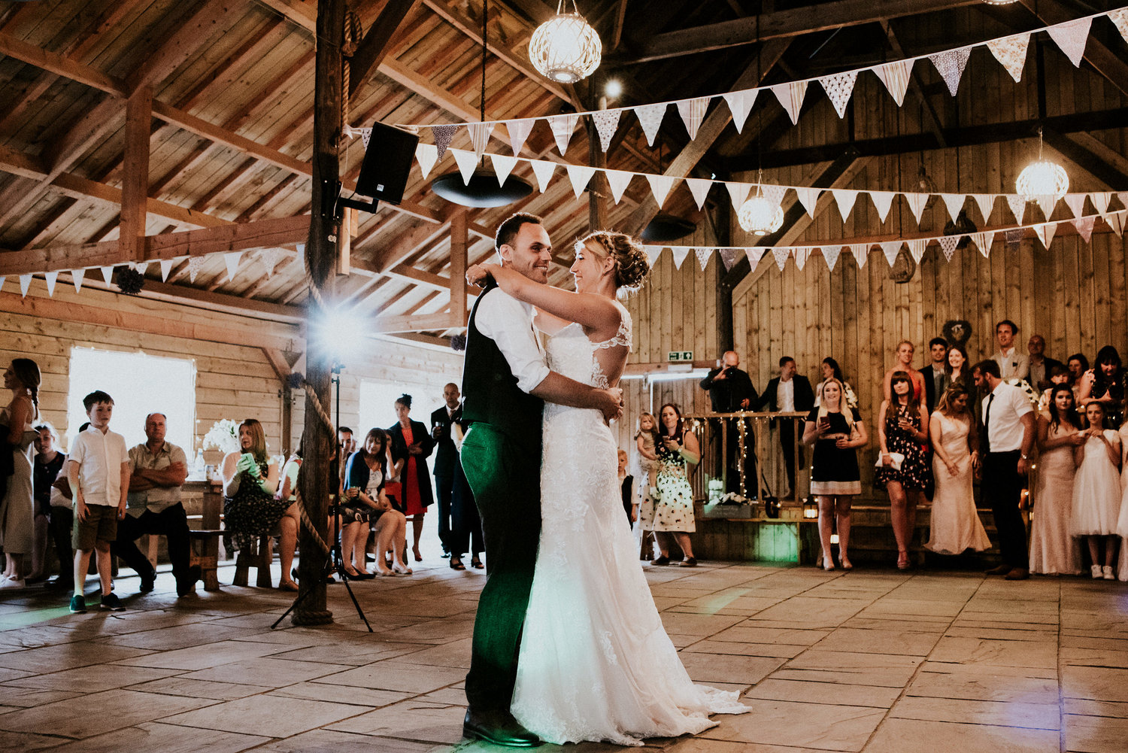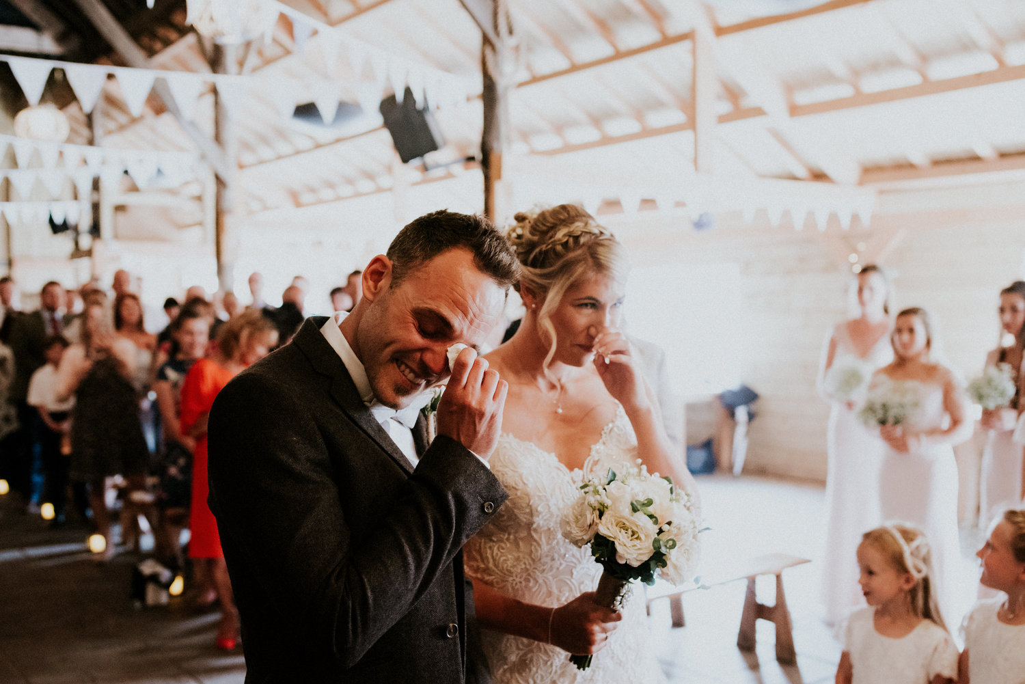 |  |  | 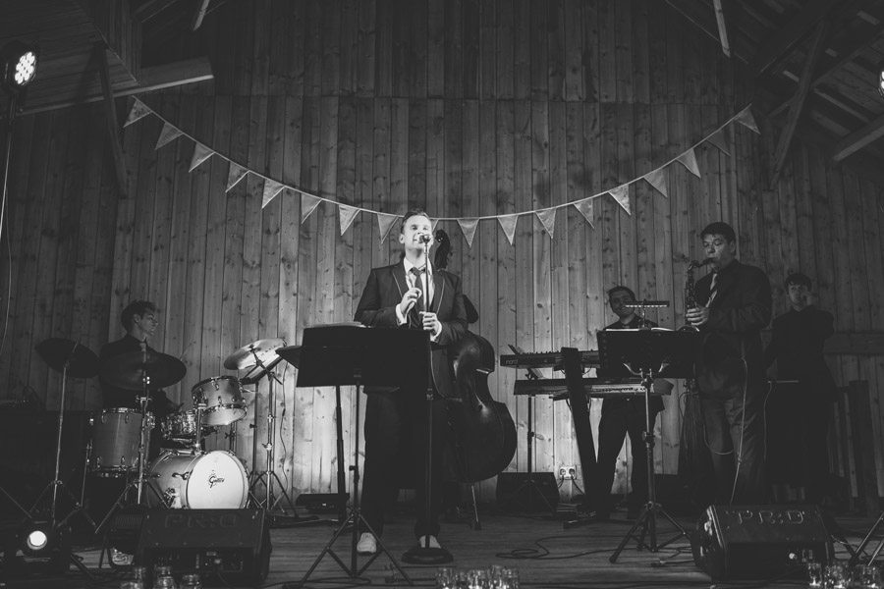  The barns are licensed for marriage and can seat up to 200 for the ceremony.  We can seat up to 160 under the terrace barn for dining and many more for the evening function if you wish.  What’s included…  The hire of the site includes all the buildings, toilets, power, heating etc as well as the tables and benches.  You also get the use of the play areas for any younger ones or big kids at the wedding.  When you hire the maze you effectively get a 3 day exclusive hire, the day before to set up, your wedding day and the day after to take down any decorations.  We have a fully stocked bar and all staff provided.
Catering…  We do all our catering in house. We have a fantastic catering team ran by Jason our catering manager.We have no set menus so you can choose exactly what you would like.  Attached are some menu ideas to help get you thinking…  http://www.yorkmaze.com/seecmsfile/?id=22  http://www.yorkmaze.com/seecmsfile/?id=21  http://www.yorkmaze.com/seecmsfile/?id=24  http://www.yorkmaze.com/seecmsfile/?id=23  For more information about your catering please contact: Jason@theamazingweddingco.co.uk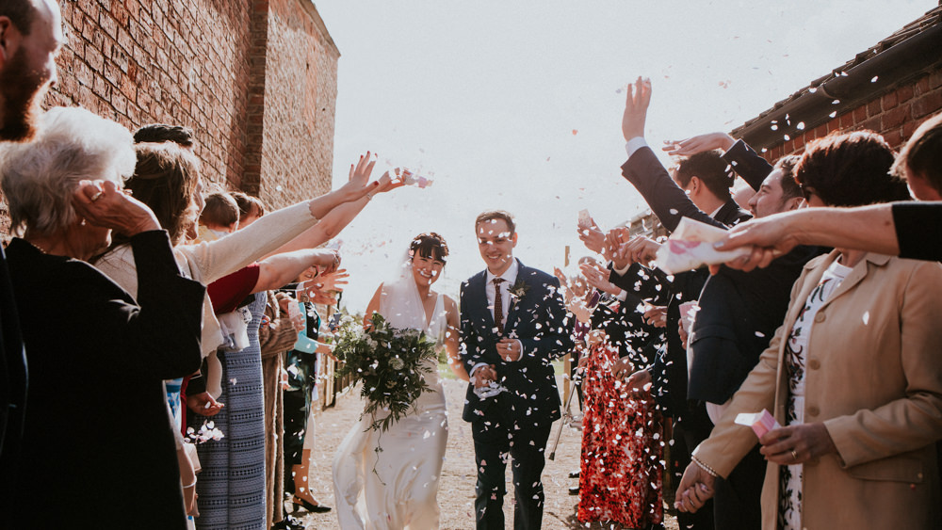  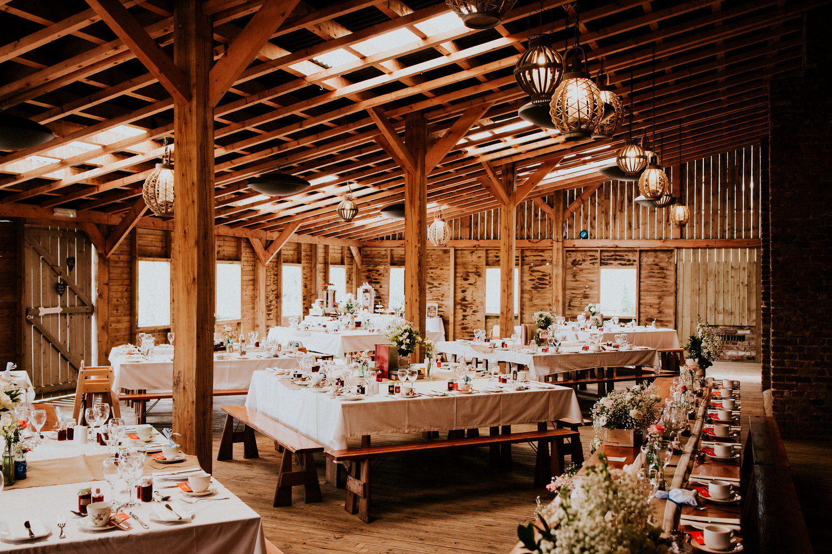 |  |  |  |  |  | Little touches…  We can help with all aspects of your wedding from Catering to entertainment, transport and photographers. We have worked with many different companies which we can recommend to you to help create your perfect day.  Also Vikki our Wedding Co-ordinator will be on hand to answer any questions or queries you have and will be with you co-ordinating your big day.  